Personal Statement information sheet

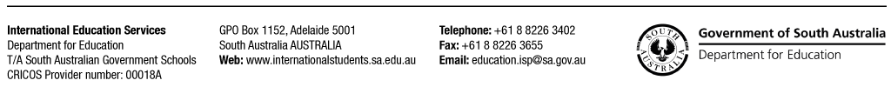

International Education Services (IES) is committed to ensuring that international students enrolling in our programs have the genuine intention to come to study with South Australian Government Schools (SAGS).

Your application to SAGS will be assessed against our program entry requirements, as well as the Genuine Temporary Entrant (GTE) requirements of the Australian Government – Department Home Affairs. This process is not designed to exclude those students who decided to continue their study in Australia and develop skills required by the Australian labour market and decide to remain in Australia under their visa conditions.

**To assist us in considering your application for enrolment, please note the following points**

* If the student is under the age of 18 years, this Personal Statement Form is to be completed by the parent/s or legal guardian. Additionally if an agent has been engaged, the form needs to be signed by the agent (only after conducting an interview with the prospective student and family).
* All questions in this Form are to be answered honestly. Please do understand that after the visa application has been submitted to the Department of Home Affairs,

information regarding the student and family’s immigration history will be reviewed. Any false information or failure to disclose information will be uncovered and this will likely result in a visa refusal.

* Agents accredited with SAGS must be aware that IES closely monitors student visa refusals, including tracking visa refusals attributable to particular agents. The status of agreements with SAGS may be reviewed based on the number of visa refusals from the agent for fraud or non-GTE reasons.
* If your student has previously had a visa refused, please disclose this in the Form. If anytime throughout the student’s enrolment process a visa refusal is issued, please contact our office immediately. Do not reapply before a new Letter of Offer and Certificate of Enrolment are issued to the applicant.

If you have any questions regarding the Personal Statement, and enrolment process please contact our office for more information.

Phone: +61 8 8226 3402

Email: [education.isp@sa.gov.au](mailto:education.isp@sa.gov.au)